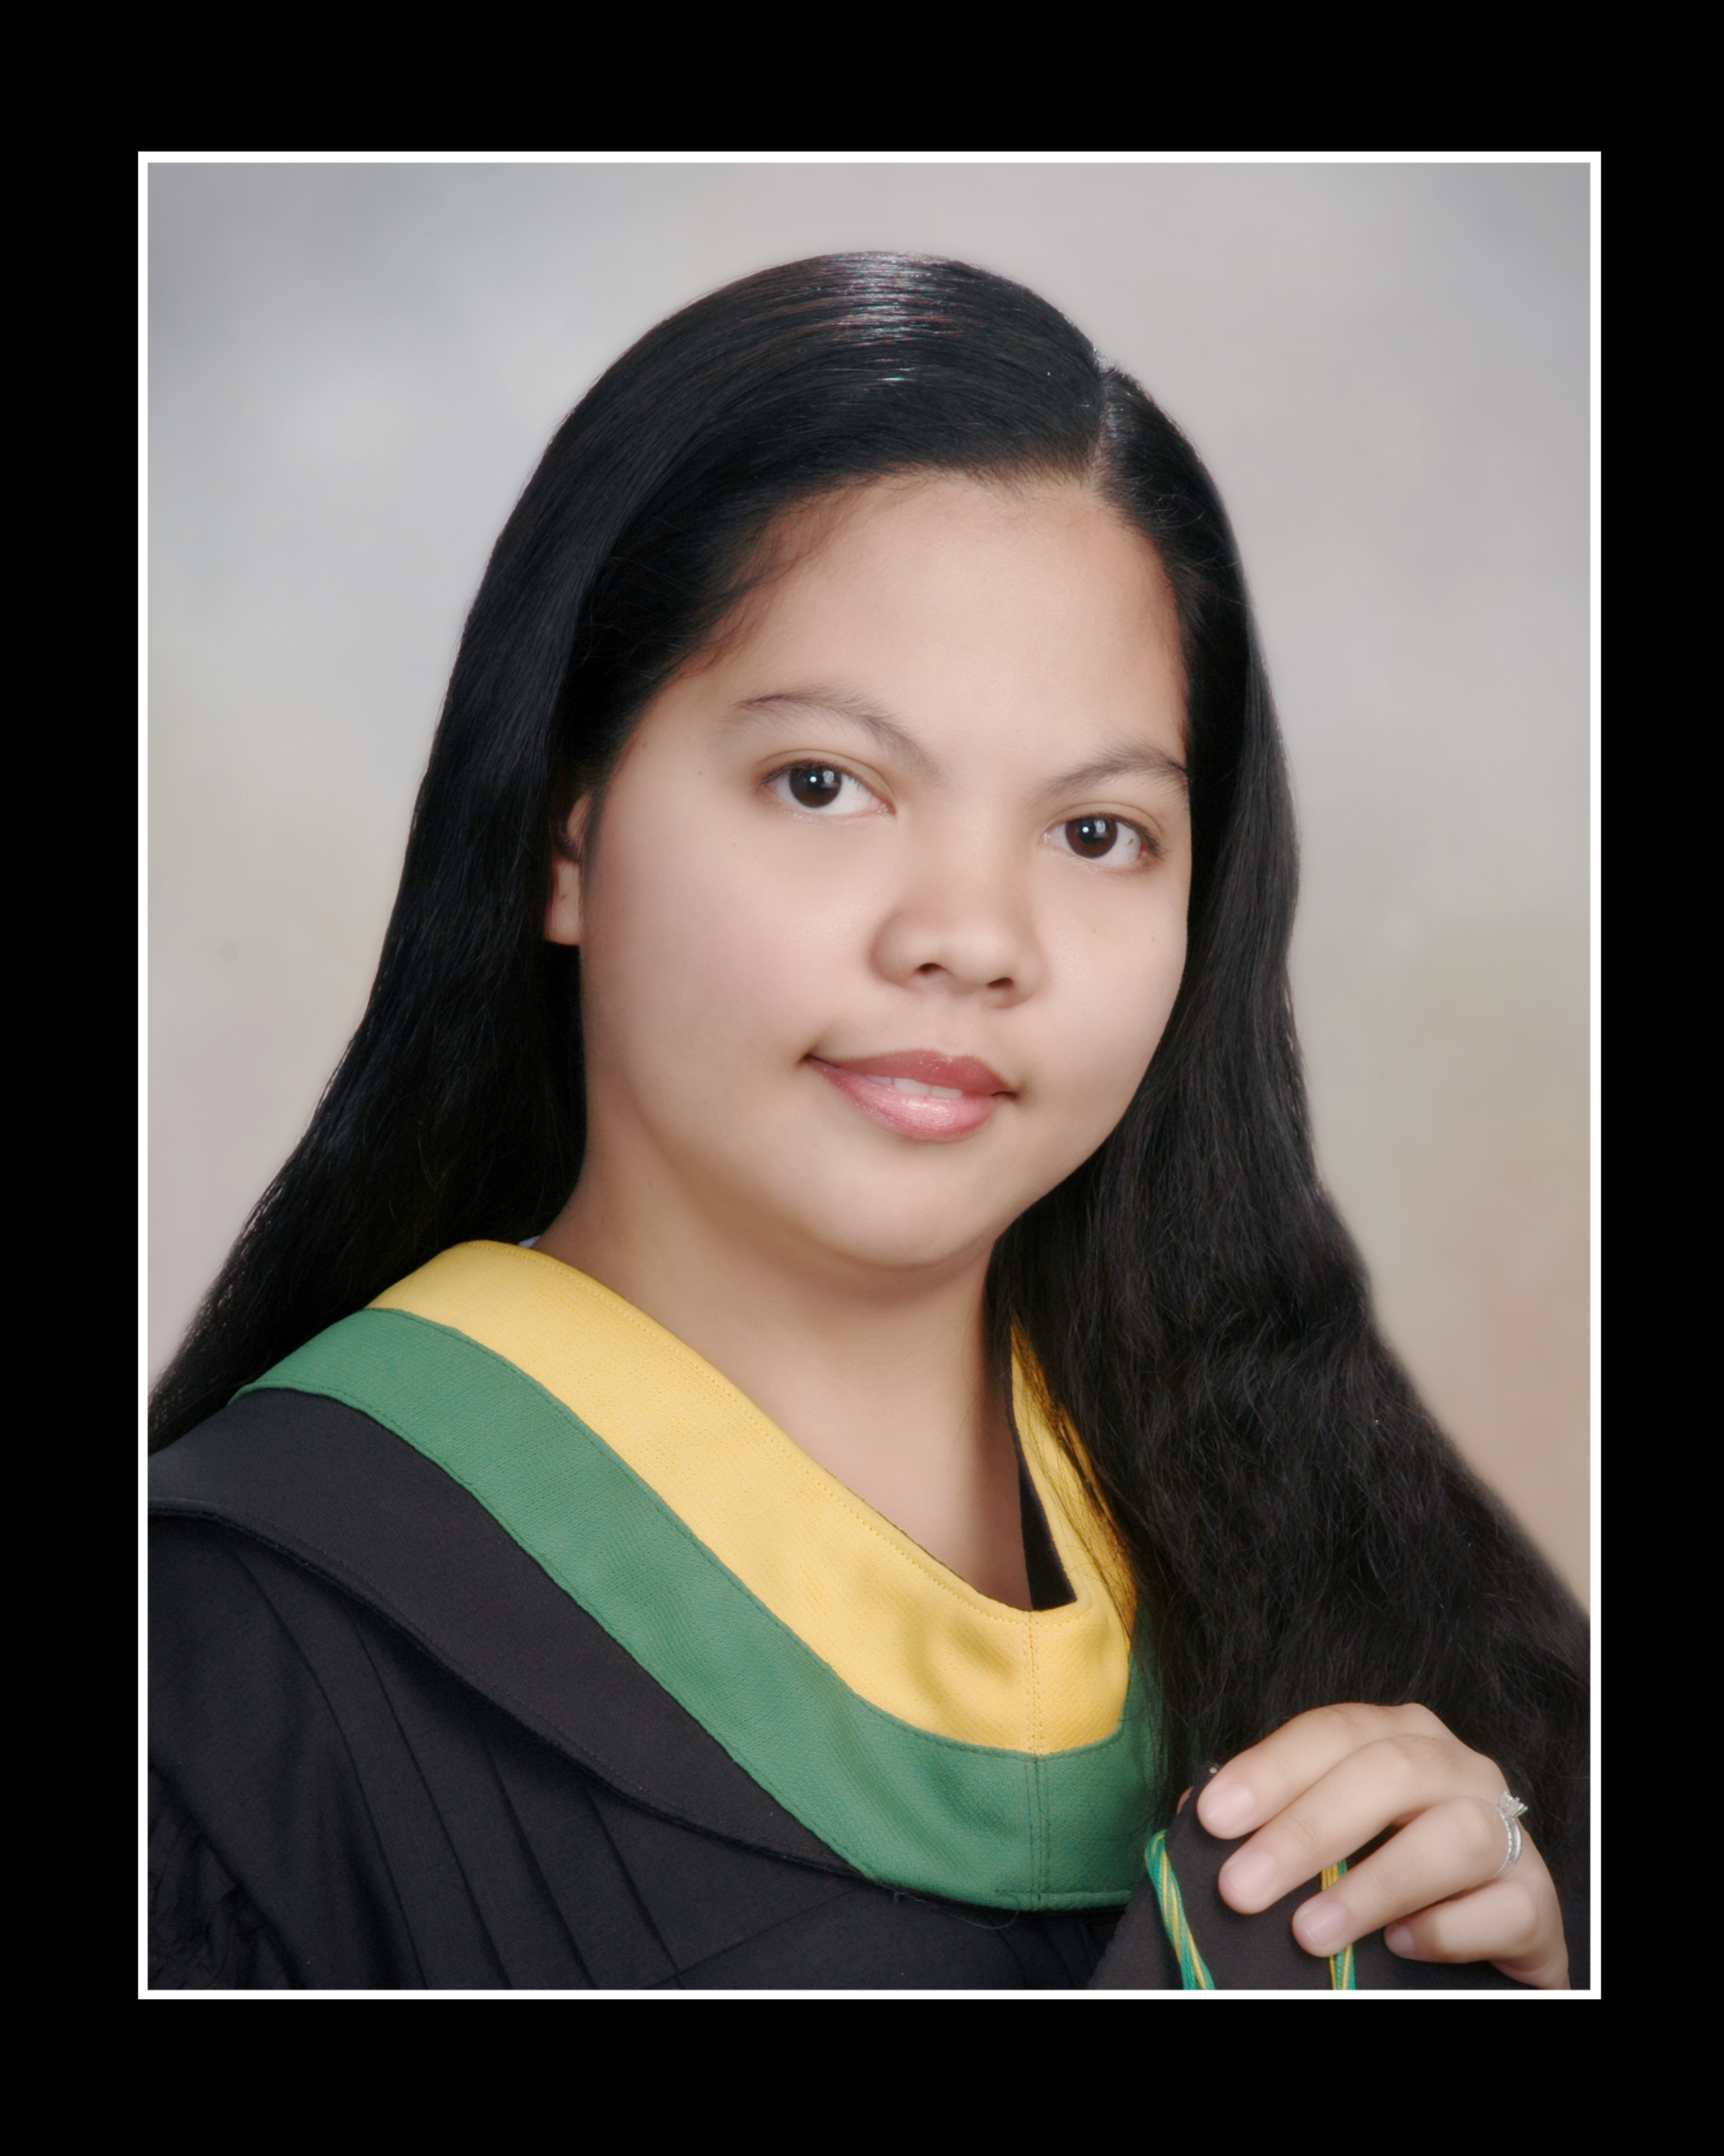
CO, MARY JANE HIRAW
Bachelor of Science in Nursing
San Fernando City, La union, Philippines
comaryjane1218@gmail.com
Contact number: +63 9156666647

CAREER OBJECTIVE:

Seeking a position in a healthcare setting. Dedicated to providing high-quality care, ensuring patient comfort, and supporting nursing staff. Eager to contribute my skills and empathy to promote a positive environment for patients and their families.

SKILLS:
Patient Care, Compassion, Communication, Teamwork, Observation, Attention to Detail, Physical Stamina, Empathy, Adaptability, Organization, Safety Awareness, Basic Life Support

WORK EXPERIENCE:
Aupair/Caregiver
Nessoden, Norway
August 2010- June 2012

Secretary
Bigtop Center
Bangued, Abra, Philippines
May 2013-November 2014

Retail Store Advisor
Vodafone Project Qatar
February 2015-November 2015

EDUCATIONAL BACKGROUND:
TERTIARY: La Union Colleges of Nursing, Arts & Sciences
Bachelor of Science in Nursing
City of San Fernando, La Union
2004-2008

SECONDARY: Gifted Learning Center
City of San Fernando, La Union
2000-2004

ELEMENTARY: Gifted Learning Center
City of San Fernando, La Union
1994-2000

LANGUAGE SPOKEN:

English and Norwegian (beginner)

CERTIFICATES:

Autorisasjon (Helsefagarbeider)
Grunnkursus i førstehjelp (First Aid)

